Crossover Fighter Overview

This is a game created by me, Arian Quader (180608270). It is a turn-based fighting game that requires strong decision making and strategy. In this game the user can face people with them, or against an AI. How it works is that the users will choose a fighter and a username, and then at the beginning of each turn, roll a dice (programmed in) to see who goes first. If your facing an AI, there’s no need to roll as you will always go first. Just press play, choose a fighter and username, then the game will highlight what to do next. When you play against the AI, you can just press any of your battle options, then the AI will react right away.

Each user has a set amount of health which comes with each fighter. The users can attack, dodge, and block. Attacking will hurt the opponent a random amount of hit points in between 1 and that fighter’s max attack. Dodging will completely save you from an attack so you don’t take any damage, but it’s risky as there is only a 1 in 3rd chance of dodging the attack. Blocking will save you a bit from the attack, decreasing the opponents damage against you by a percent from 0 to you fighter’s max block stat. They can heal after 3 turns, regaining or exceeding your health by 0 to your max heal potential. After 5 turns you can use your fighter’s designated ultimate. Each fighter’s ultimate is unique, where they can heal, attack or/and block, so choosing a fighter based on health and ultimate information is important. Whoever gets the opponent to 0, or has the most health after 50 turns wins. In a rare case, a tie occurs when both users go below 0 in the same turn, or both users have the exact same health after 50 turns (which is very unlikely).

After a game is finished, the user can check out the stats of that game. They can view all stats per round, the results, and they can even see a graphical version of each stat.

A database saves all the fighter information like how much health, max attack, and max block each specific fighter has. It also saves their mostly unique ultimate, and what they do. The database will also save each user's stats like usernames, wins, losses, rounds played, damage taken, damage healed, and more. It is assumed that each user who attempts to run the application has this database with the name “GameData.mdb”. Its vital as the game won’t run without the fighters.

If players want to download more fighters, they can get custom fighters from DLC packs imported in through a CSV file. These are to be saved into the database to be used in-game.

A word report can be made with all the user stats, leaderboards, and the previous game stats. It can display graphs of the win rates and such in histograms.

Other assumptions that can take place are that the user will only touch the buttons on the worksheets. Once done they can be given dialogs or user forms where they can press anything, but nothing on the worksheets will be altered by the user. This will only mess up the automated word report.

How the program works, is that the user will press play, where a menu user form opens. This user form gives three options. Importing will cause the program to allow you to choose which dlc file data to save into the database. Play against an AI or friend will bring up the player select user form. Fighter names get loaded up. Here player 1 can choose their fighter and username. Player 2 can if they are being used, but a COM will be present if they aren’t. After both users lock in (or player 1 locks in for both), you can fight. If you are facing a COM you get a com battle user form. If you aren’t you get a normal battle user form. All fighter info gets loaded up. You roll or not with the button, after you have to choose whether to attack, block, dodge, heal or ultimate. After the game ends, the post game stats worksheet will update, and you can press graph to graph your stats. The moment the game ends, all stats are saved into the database.

Here are what the user forms look like:

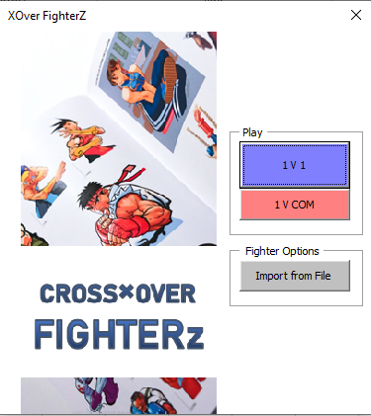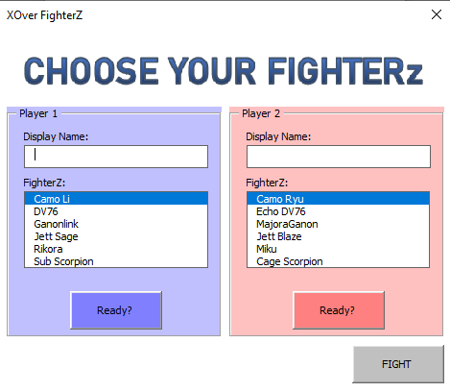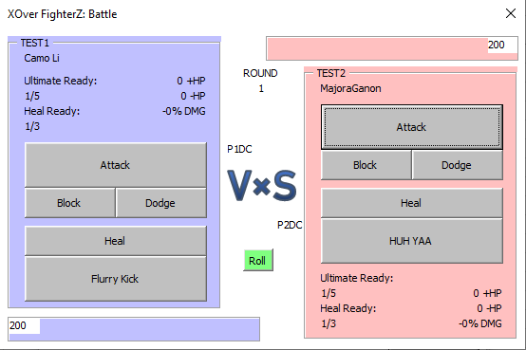

The report shows any stats on the worksheets. This include:

* Recent stats table
* Recent stats results table
* Recent game damage dealt, healed and blocked graphs
* Winner leadorboards
* Winrate leaderboards
* And other graphs from database